Patient Information
Breathlessness __________________________________________________________________________________
Factsheet 1: The breathing thinking functioning (BTF) approach
This information is designed to help you manage your stable long-term breathlessness. If your breathing is getting worse, or if your breathlessness is a new feeling, it is important to seek medical advice from your GP.
___________________________________________________________________________
Introduction
Breathlessness is unpleasant and can be a difficult symptom to live with. There are ways you can reduce the impact that breathlessness has on your life but unfortunately sometimes the way we try to cope can worsen the feeling.
It is important to understand how breathlessness develops. This understanding can then lead to you finding ways to help and be in control of your breathing.

The breathing, thinking, functioning model
The fight or fight response plays a critical role in how we deal with stress and danger in our environment. Our bodies get primed for action with an increase in our heart rate and our breathing becomes deeper and quicker. The fight or flight response can kick in when we experience something frightening or when there is a threat to our survival e.g., suffocation.
When people have chronic conditions that affect the heart and lungs, this coping behaviour is less helpful and can cause development of emotions and behaviours that actually make the breathlessness worse.
The control of breathing is complex, and so too are the mechanisms which cause us to feel breathless. How the feeling of breathlessness is created is not fully understood however we know that breathlessness can impact upon our thoughts, the way we breathe and how we go about our daily activities.
Three areas are explained in this factsheet: ‘Breathing,’ ‘Thinking,’ and ‘Functioning.’ In each of these areas, unhelpful emotions and behaviours develop and lead to vicious cycles that are intertwined and ultimately worsen the feeling of breathlessness.

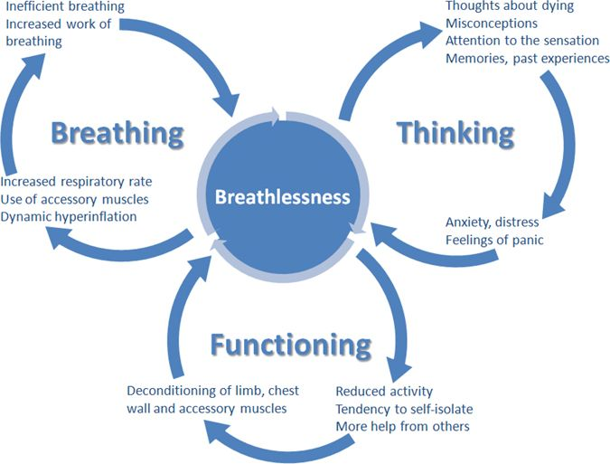

- Breathing
Being breathless can often lead to the development of an inefficient breathing pattern. A common sensation is the feeling that there is a need for ‘more air.’ We tend to pant with our shoulders hunched, small breaths coming in and out of only the top part of our chest. The muscles that support breathing (see Factsheet 3), particularly around the neck and shoulders are over-used in an attempt to pull more air in. This increases the effort of breathing and makes it less efficient.
In conditions like chronic obstructive pulmonary disease (COPD), there is not enough time for the lungs to empty when breathing fast. The next breath in starts before the lungs have fully emptied. This causes breaths to stack on top of each other, which makes the chest too full and breathing feels even less comfortable. This leads to an increase in the effort needed to breathe and makes recovery longer.
There are things that can help to improve your breathing pattern. These include breathing techniques, cooling the face with a fan, and finding a comfortable position.

- Thinking
Feelings of breathlessness almost always lead to a sense of anxiety or panic. The areas of the brain involved in the feelings of breathlessness also process our emotions. Feeling anxious or frightened will directly impact upon breathlessness. This well-recognised vicious cycle can lead to panic, and faster breathing. Anxiety increases the tension in our muscles which increases the effort of breathing.
Things that can be helpful include relaxation techniques, gradually slowing your breathing, and finding a calm state of mind.

- Functioning
Breathlessness is an unpleasant sensation, and it is natural to try to avoid it by reducing our activity levels. This leads to all our muscles becoming weaker and these weakened muscles use oxygen less efficiently and are not able to do their job as well. This muscle weakness and deconditioning will increase breathlessness.

Our family and carers try to help by doing the activities that we might otherwise have done, thereby further reducing our activity.
It can help to understand that getting moderately breathless by being active is not harmful and can actually improve breathlessness over the longer-term. Regular exercise or walking more can also be helpful.

Contacts/further information
Other factsheets in this series will go through these techniques in more detail.
If you would like this information in large print, please contact Teesside Hospice on 01642 811060.

Acknowledgement
This document has been reproduced and adapted from the patient information leaflets developed by the Cambridge Breathlessness Intervention Service, Cambridge University Hospitals NHS Foundation Trust / Addenbrooke’s Hospital, with kind permission.

Developed 11/2022
Review 11/2024

